 | Prenatal Breast-feeding classes | Breastfeeding Support Group | Breast pump rental / purchase | Private Breastfeeding Consultations | Breastfeeding Supplies or  Gifts | Contact Information  Link to Website or Calendar of Events
Humboldt General Hospital | Yes, monthly | Stay tuned, coming soon | No | Yes, schedule with Becky Egbert at (775) 455-5138  or call Mother and Baby Unit | Yes at delivery | Mother and Baby Unit: (775) 623-5222, ext. 1268  Main Hospital (775) 623-5222  https://www.hghospital.org/
Babies R US, Reno | No | No | Yes - Both | No | Yes - Both | (775) 825-2229
Nevada WIC | Yes | No | Yes, if eligible WIC participant | Yes, CLE on site  Pacify App option if WIC eligible | Yes | (775) 625-2722  Nevadawic.org
Pacify 24-hour Breastfeeding Help |  |  |  | Yes via phone using video consultation with IBCLC |  | https://pacify.com/  App available for Apple and Google Play  *Fee for non WIC participant
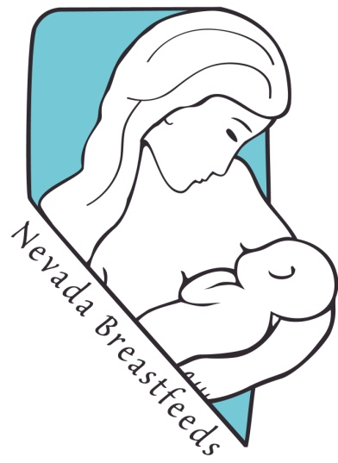

NevadaBreastfeeds.org
Kellymom.com
DrJacknewman.com

Infant Risk Center – (for breastfeeding / medicine compatibility) (806) 352-2519 or www.infantrisk.com

Additional Helpful Resources

National Breastfeeding Helpline: (800) 994-9662
24 Hour REMSA Nurse Hotline: (775) 858-1000

Breastfeeding Resources for Winnemucca, NV
Breastfeeding is a wonderful way to support the growth of your child while nurturing a bond that will last a lifetime. Northern Nevada wants to encourage mothers to breastfeed and has many resources for women who may need some additional support or for moms going back to work or school.

