 | Prenatal Breast-feeding classes | Breastfeeding Support Group | Breast pump rental / purchase | Private Consultations | Breastfeeding Supplies or  Gifts | Contact Information  Link to Website or Calendar of Events
A Nurturing Space (Carson City) | Yes | Thurs 1:30 PM |  | Yes |  | (775) 546-2850 or (775) 720-4625  http://www.carsonmidwifery.com/
Nevada WIC  (*WIC participants only) | Yes* |  | Yes* | Yes* | Yes- Supplies* | (775) 684-5942  nevadawic.org
Carson Tahoe Regional Medical Center | Yes | Mon 5:30 PM  Wed 10 AM |  | Yes |  | (775) 445-5122 – Breastfeeding Warm Line  http://www.carsontahoe.com/pages.php?var=Breast-Feeding
La Leche League of Northern Nevada |  | 2nd Mon each month, 10-11 AM @ HOPES |  | Yes |  | lllnorcal.org/Groups/NorthernNevada.html
Meredith Pollaro, OTR/L, IBCLC, RLC | Yes | Mon 12 PM @  Nurturing Nest |  | Yes | Yes | (775) 453-4628
ITCN WIC  (*WIC participants only) | Yes* | *varies | Yes* | Yes*  walkins | Yes- Supplies* | (775) 355-0600  http://itcnwic.org/
The Nurturing Nest | Yes | Mon 12 PM |  | Yes | Yes - Both | (775) 825-0800  www.nurturingnestreno.com
Renown Regional Medical Center /  Lactation Connection | Yes | Tues 4 PM  Thurs 11 AM  (Main hospital) | Yes - Both | Yes | Yes - Both | (775) 982 –5210 – Lactation Connection  www.renown.org/thelactationconnection  (775) 982-5483 – Breastfeeding Warm Line  www.renown.org/ChildbirthEducation
Saint Mary’s Regional Medical Center | Yes | Thurs 10 AM  2nd & 4th Thurs 6 PM | Yes - Both | Yes | Yes | (775) 770-3751 - Breastfeeding Warm Line  (775) 770-3109 – Pump Rental  www.saintmarysreno.com/Events-Calendar/Event-Details.aspx?Event=16
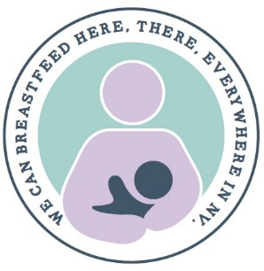
Rev.4/9/18
Breastfeeding Resources for Reno / Sparks / Carson City

Nursing bra fitting - Lactation Connection (775) 982-5210
Bras Plus (775) 324-3332
Infant Risk Center – (for breastfeeding / medicine compatibility)
(806) 352-2519 or www.infantrisk.com

NevadaBreastfeeds.org
Kellymom.com
DrJacknewman.com

Additional Helpful Resources
National Breastfeeding Helpline: (800) 994-9662
24 Hour REMSA Nurse Hotline: (775) 858-1000

