 | Prenatal Breast-feeding classes | Breastfeeding Support Group | Breast Pump Rental/ Purchase | Private Consultations | Breastfeeding Supplies or Gifts | Contact Information  and  Link to Website
Family Resource Center  Elko Women Infants and Children (WIC) *WIC Participants Only |  |  |  |  |  | (775) 777-8833  www.elkofrc.org or facebook.com/elkowic
ITCN Women Infants and Children  *ITCN WIC Participants Only |  |  |  |  |  | (775) 738-5000  http://itcnwic.org/
Lynn Hoffman  MS, CLE, IBCLC |  |  |  |  |  | (775) 738-3920  Lactlynne@gmail.com
Northeastern Nevada Regional Hospital  (NNRH) |  |  |  |  |  | Alyssa Fedel RN, BSN, CLC  Breastfeeding Counselor  (775) 738-5151  alyssafedel@gmail.com
Sterling Doula  Services  Angela Adams |  |  |  |  |  | (775) 397-5547  sterlingdoula@gmail.com  https://www.stillbirthday.com/
Pacify  24 - Hour Breastfeeding  Help |  |  |  |  |  | App avaliable for Apple and Google play  https://pacify.com/
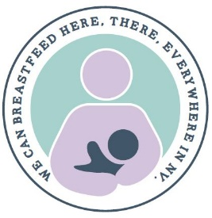
Breastfeeding Resources for Elko, Nevada
Breastfeeding is a wonderful way to support the growth of your child while nurturing a bond that will last a lifetime. We want to encourage mothers to breastfeed and provide resources for women who may need some additional support or for the mom that is going back to work or school.
Additional Helpful Resources: Infant Risk Center: (806) 352-2519 Kelly Mom: kellymom.com
Breastfeeding Helpline: (800) 994-9662 Dr. Jack Newman: drjacknewman.com
Nevada Breastfeeds: nevadabreastfeeds.org
Le Leche League: http://www.llli.org/

