 | Prenatal Breast-feeding classes | Breastfeeding Support Group | Breast pump rental / purchase | Private Breastfeeding Consultations | Breastfeeding Supplies or  Gifts | Contact Information  Link to Website or Calendar of Events
Banner Churchill Community Hospital | Yes Monthly 4th Tuesdays | Stay tuned, support group to come | No | Yes, see Kendi Yates | Yes at delivery | Labor and Delivery 867-7232  Pediatrics 867-7712  *To register for Breastfeeding class, call Kelly Yates 867-7401
Babies R US, Reno | Yes |  | Yes - Both |  | Yes - Both | (775) 825-2229
Care Net Pregnancy Care Center of Churchill County | Varies | No | Yes, if earned with points | No | Yes | (775) 423-4357  75 N Ada St Fallon, NV 89406  falloncarenet@yahoo.com
Kendi Coverston-Yates CMA, CLC | No | No | No | Yes | No | Available for private consultations  by appointment: 775-867-7718  801 E. Williams Ave. Fallon, NV 89406
La Leche League of Northern Nevada | No | Various | No | No | No | http://www.llli.org/help_form  http://lllnorcal.org/groups/northernnevada.html  CarsonvalleyLLL@gmail.com  Kristen 775 473-4809, Danna 775 348-1593  Helen (Hablo Espanol) 775 387-0286
Nevada WIC –Fallon Office  (*WIC participants only) | Yes* | Yes* | Yes* | No | Yes- Supplies* | (775) 423-7067 485 W B St, Fallon, NV 89406  Nevadawic.com  *Staff are trained in breastfeeding education and support. Breast pumps are available for many breastfeeding moms, including those who are separated from their infant for medical reasons or if the mother returns to work or school. Enhanced food packages are offered to breastfeeding moms.
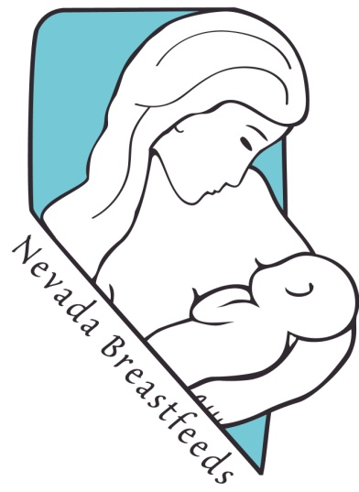
Additional Helpful Resources

National Breastfeeding Helpline: (800) 994-9662
24 Hour REMSA Nurse Hotline: (775) 858-1000

NevadaBreastfeeds.org
Kellymom.com
DrJacknewman.com

Nursing bra fitting – Renown Lactation Connection (775) 982-5210
Bras Plus (775) 324-3332
Infant Risk Center – (for breastfeeding / medicine compatibility)
(806) 352-2519 or www.infantrisk.com

Breastfeeding Resources for Fallon, NV
Breastfeeding is a wonderful way to support the growth of your child while nurturing a bond that will last a lifetime. Northern Nevada wants to encourage mothers to breastfeed and has many resources for women who may need some additional support or for moms going back to work or school.

